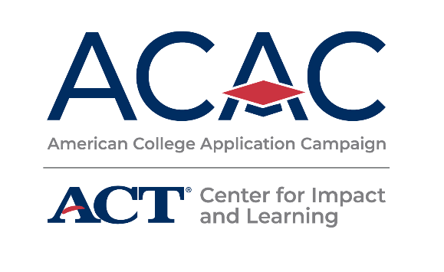

**FAFSA Completion Event Reminders**

**[Name of State’s FAFSA Completion Event]**

**[FAFSA Completion Event’s Logo]**

**Assistance with Your Free Application for Federal Student Aid (FAFSA)**

[If your state offers state aid for undocumented and DACAmented students, consider including support for that financial aid application in this event]

Date: [FAFSA Completion Event Date]

Time: [FAFSA Completion Event Time]

Location: [Nearest location]

Contact Info

Host: [FAFSA Completion Event Group or Organization]

Contact Phone Number: [Phone Number for FAFSA Completion Event]

Contact Email: [Email for FAFSA Completion Event]

**What to Bring**

The following items are what you should bring to the event.

* Your FSA ID, if you have already applied and been assigned one. The FSA ID is a username and password you use to log in to the U.S. Department of Education online systems. You may have registered for your FSA ID during [Name of State’s ACAC program]. If you do not already have an FSA ID or if you have forgotten your FSA ID and need to retrieve it, you can go here: https://studentaid.gov/fsa-id/create-account/launch. Be sure to do this prior to the event!
  + Note that students and parents each need their own FSA ID.
* Your Social Security Number (SSN).
* Your driver's license (if any).
* Your current bank statements.
* Your current business and investment mortgage information, business and farm records, stock, bond and other investment records.
* Your resident alien registration or permanent resident card (if you are not a U.S. citizen and are eligible for federal aid).
* [Include any additional information undocumented or DACAmented students need to apply for state aid.]

For more information, visit the [Name of State’s FAFSA Completion Event] website here:

[FAFSA Completion Event Website]