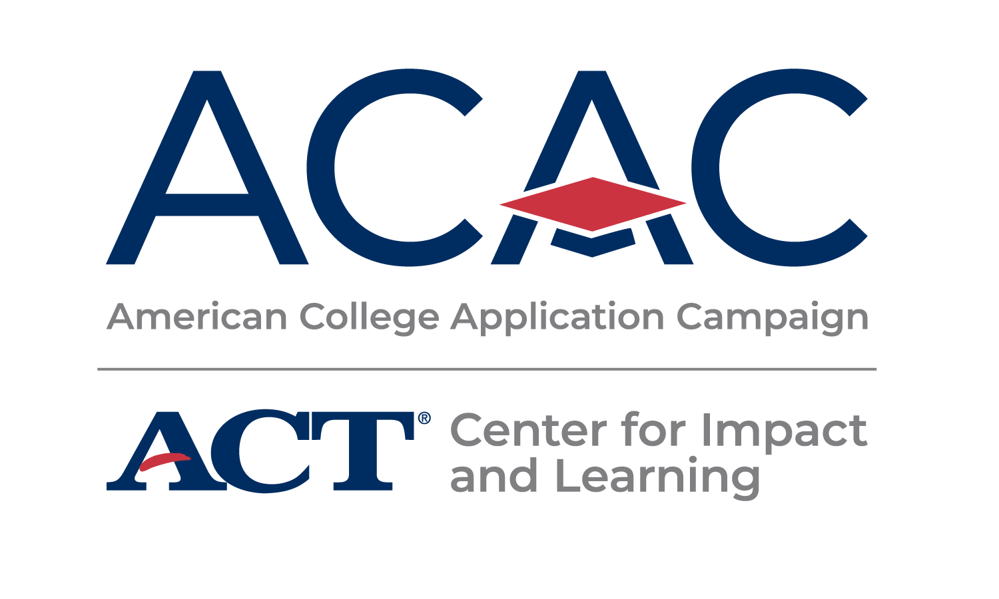

**NEWSLETTER SAMPLE COPY**

At <ORGANIZATION NAME>, we believe every learner should have the opportunity to discover and fulfill their college and career dreams, and we know school staff are the best support system to help learners achieve this goal. We’re excited to partner with the American College Application Campaign (ACAC), an initiative of ACT’s Center for Impact in Learning, for **#WhyApply Day 2025**.

ACAC supports learners and those who strive alongside them — counselors, college advisors, educators, and community allies — from thousands of areas across the country to organize events that encourage students to apply to college and support them throughout their application process. To celebrate the nearly 480,000 students who will participate in these application events, #WhyApply Day kicks off the application season and provides encouragement for these dedicated learners.

This year, #WhyApply Day is on **Friday, Sept. 19**. Show your support by wearing your college gear and sharing why you believe students should apply to college and/or providing inspirational encouragement with why you applied to college, using the hashtag #WhyApply on social media.

Not sure what to post? Try these tips to express your motivation in engaging ways:

* Type a short response in your status.
* Make a video of yourself, your kids, or your friends answering the question.
* Draw a picture illustrating your reasons.
* Write your answer on a piece of paper (feel free to use the [#WhyApply template](https://impactandlearning.act.org/wp-content/uploads/2022/05/why-apply-selfie-printout-2025-.pdf) provided) and post a photo of you holding it.
* Share an image or photo with your reason.

For more resources, including social media post templates, visit <https://impactandlearning.act.org/acac/resources/why-apply/>.

Your participation in #WhyApply Day and your year-round support for learners make a significant impact on their lives. By helping them feel capable and confident as they prepare to take the next step in their educational journey, you contribute to their success. Should you have any questions, please don't hesitate to reach out to our office.

Join us in empowering students, and let’s make #WhyApply Day 2025 a memorable and impactful event!