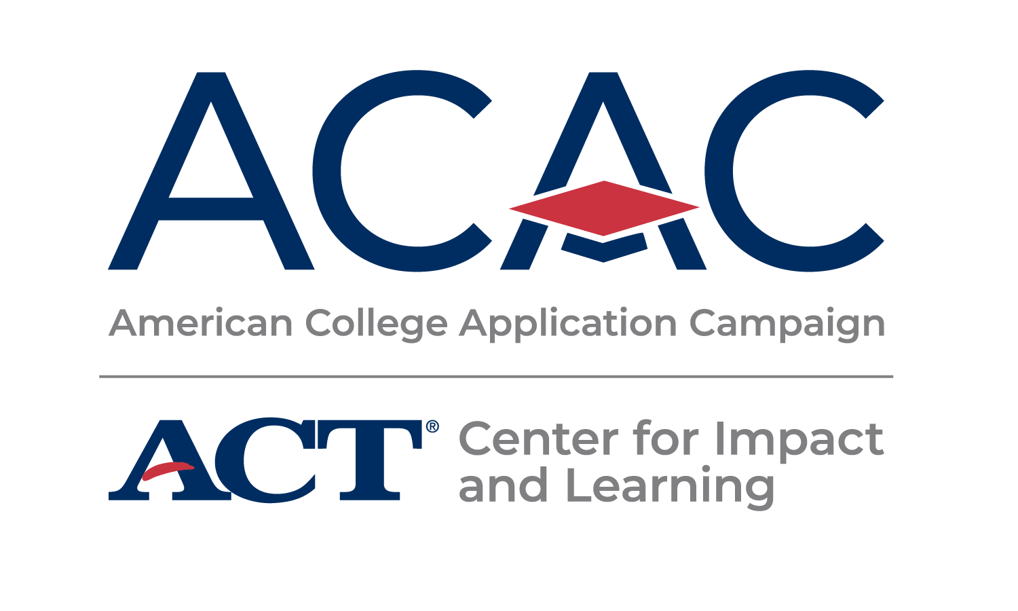

**#WhyApply 2025 Social Media Toolkit**

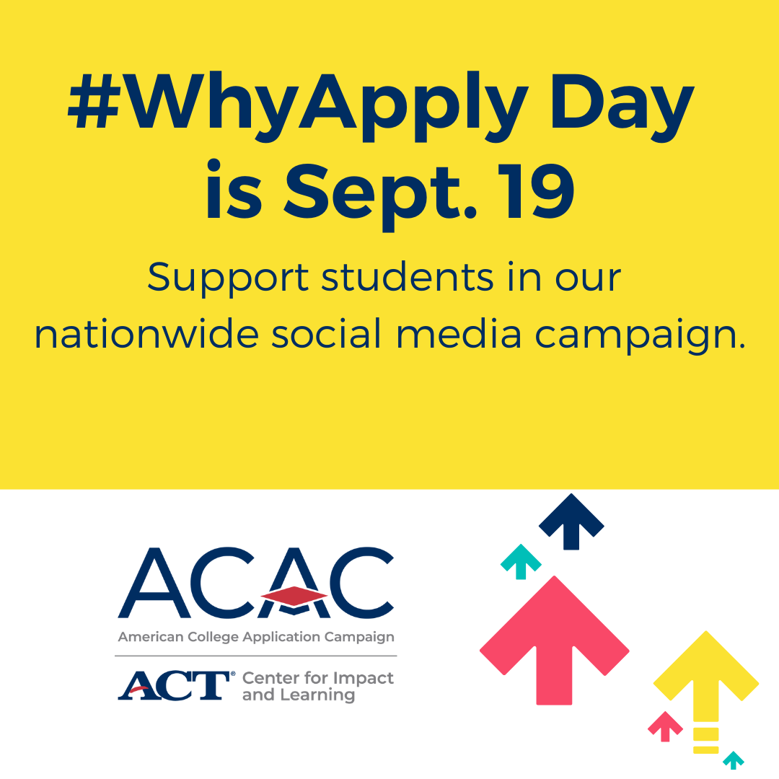This fall, students across the country will be submitting college applications and celebrating their plans for the future. Hundreds of thousands of them will do so when schools in nearly all 50 states and the District of Columbia host American College Application Campaign (ACAC) events. To celebrate college application season and our students, ACAC encourages participating in the [#WhyApply social media campaign.](https://impactandlearning.act.org/acac/resources/why-apply/)

**Join ACAC on Friday, Sept. 19, 2025, for #WhyApply Day**   
**by heading to social media and answering the question, “Why apply to college?”**  
  
#WhyApply Day celebrates the college application season by sharing supportive and motivating messages on social media about the importance of applying to college. Whether a student is applying to a two- or four-year college or university, it is important to celebrate this critical and necessary step on the journey.

**How You Can Participate**

**1. Share your #WhyApply on social media.**

1. Print a [#WhyApply Selfie Printout](https://impactandlearning.act.org/wp-content/uploads/2022/05/why-apply-selfie-printout-2025-.pdf) or use a blank piece of paper with the hashtag on it.
2. Write your response to the question “Why apply to college?” on it.
3. Put on your college gear and take a photo with your #WhyApply statement.
4. **On Sept. 19, post your photo or statement** to your personal or organization’s social media channels using the hashtag #WhyApply and tag the American College Application Campaign.
   1. X: [@American_CAC](https://twitter.com/american_cac) | Facebook: [@americancac](https://facebook.com/americancac) | Instagram: @American_CAC

**_____________________________________________________________________________**

**Sample posts to use on #WhyApply Day:**

First you apply, then you succeed Because I wanted to make a difference

College enriches your life and your mind Because everyone is college material

College increases financial stability To keep learning and growing

*Get creative! We love seeing the pictures and your smiling faces, but there are other ways to participate. If you’re camera-shy, draw a picture or simply update your status. If you prefer video, share a brief video with your #WhyApply statement.*

|  |  |
| --- | --- |
|  |  |

**2. Promote #WhyApply on social media (share images/text).**

Help us spread the word to ensure as many educators and mentors join in the celebration as possible! Post on social media one to two weeks before #WhyApply Day to invite others to share their experiences on Sept. 19.

|  |  |
| --- | --- |
|  |  |

**3. Invite colleagues and networks to share their #WhyApply.**

Send an email to your staff or include #WhyApply in your newsletter one to two weeks before #WhyApply Day. Copy and paste the image below or download other images at <https://impactandlearning.act.org/acac/resources/why-apply/>.

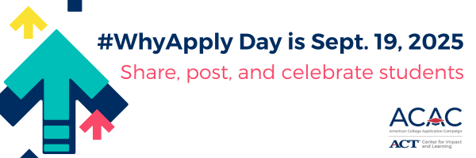

**Sample newsletter copy (short form/blurb):**

Why apply to college? Join <ORGANIZATION NAME> and ACT’s [American College Application Campaign](https://impactandlearning.act.org/acac/) in celebrating **#WhyApply Day on Friday, Sept. 19**. Encourage students by sharing why you applied to college or why students should apply to college on social media. Use the template or make a video. Post with the #WhyApply hashtag and help inspire students as they begin their college applications. [Learn more.](https://impactandlearning.act.org/acac/resources/why-apply/)

**Sample newsletter copy (long form):**

**Subject line: Celebrate #WhyApply Day September 19, 2025**

At <ORGANIZATION NAME>, we believe every learner should have the opportunity to discover and fulfill their college and career dreams, and we know school staff are the best support system to help learners achieve this goal. We’re excited to partner with the [American College Application Campaign](https://impactandlearning.act.org/acac/) (ACAC), an initiative of ACT’s Center for Impact in Learning, for [#WhyApply](https://impactandlearning.act.org/acac/resources/why-apply/) Day 2025.

ACAC supports learners and those who strive alongside them — counselors, college advisors, educators, and community allies — from thousands of areas across the country to organize events that encourage students to apply to college and support them throughout their application process. To celebrate the nearly 480,000 students who will participate in these application events, #WhyApply Day kicks off the application season and provides encouragement for these dedicated learners.

This year, #WhyApply Day is on Friday, Sept. 19. Show your support by wearing your college gear and sharing why you believe students should apply to college and/or providing inspirational encouragement with why you applied to college, using the hashtag #WhyApply on social media.

Not sure what to post? Try these tips to express your motivation in engaging ways:

* Type a short response in your status.
* Make a video of yourself, your kids, or your friends answering the question.
* Draw a picture illustrating your reasons.
* Write your answer on a piece of paper (feel free to use the #WhyApply template provided) and post a photo of you holding it.
* Share an image or photo with your reason.

For more resources, including social media post templates, [download the toolkit](https://impactandlearning.act.org/acac/resources/why-apply/).

Your participation in #WhyApply Day and your year-round support for learners make a significant impact on their lives. By helping them feel capable and confident as they prepare to take the next step in their educational journey, you contribute to their success. Should you have any questions, please don't hesitate to reach out to our office.

Join us in empowering students, and let’s make #WhyApply Day 2025 a memorable and impactful event!

**Contact:**   
Lisa King, Director,   
American College Application Campaign

lisa.king@act.org