
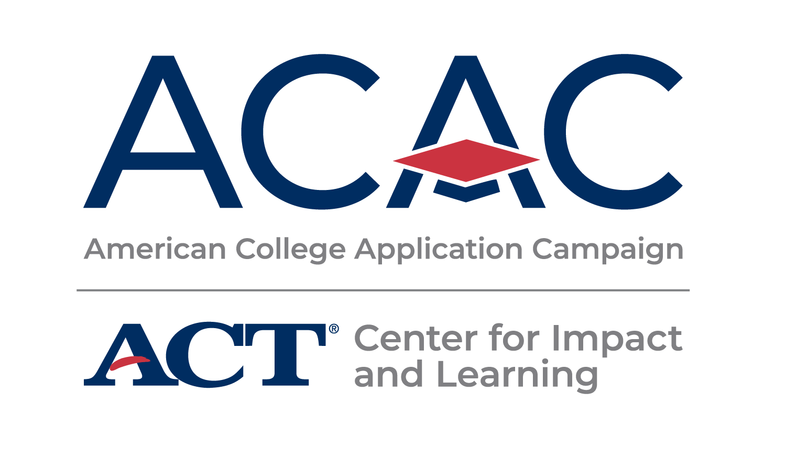

503 E Locust Street
Bloomfield, IA 52537

March 2025

Dear Students and Families,

Davis County High School has been invited by the American College Application Campaign (ACAC) to participate in a college match and fit program for high school juniors. This event is possible due to the collaborative efforts of the administration, faculty, and staff at DCHS to support all students in navigating plans for life after high school.

The purpose of College Match Day is to communicate the importance of building a list of postsecondary options that are a match and fit for your student’s interests and learning goals. It is our goal to have every student leave the final event with a list of potential postsecondary institutions they may apply to during the fall of their senior year.

March 15th
Activity #1: Students will hear from a DC graduate panel on their postsecondary journeys, start identifying their personal goals & what aspirations they have for their postsecondary journey.

April 25th
Activity #2: Students will reflect on their previous goals and start researching colleges of interest. Students will use a college & career planning resource to help guide them.

May 23rd
College Match Day Event: Students will declare their top 3 post-secondary institution choices by determining the best fit, cost, and match for their postsecondary goals.

If you have any questions please contact Marla Wilfawn at Marla.Wilfawn@dcmustangs.com or Taylor Utt at Taylor.Utt@indianhills.edu or 641-208-4479.
Thank you in advance for your support of this exciting initiative to encourage all Iowa students to make college a part of their future!

Sincerely,
Marla Wilfawn, School Counselor Taylor Utt, College & Career Transition Coach

